What is RDBMS (Relational Database Management System)
RDBMS stands for Relational Database Management System.
All modern database management systems like SQL, MS SQL Server, IBM DB2, ORACLE, My-SQL, and Microsoft Access are based on RDBMS.
It is called Relational Database Management System (RDBMS) because it is based on the relational model introduced by E.F. Codd.

How it works
Data is represented in terms of tuples (rows) in RDBMS.
A relational database is the most commonly used database. It contains several tables, and each table has its primary key.
Due to a collection of an organized set of tables, data can be accessed easily in RDBMS.

Brief History of RDBMS
From 1970 to 1972, E.F. Codd published a paper to propose using a relational database model.
RDBMS is originally based on E.F. Codd's relational model invention.
Following are the various terminologies of RDBMS:

Introduction of Relational Model and Codd Rules in DBMS
• Read
• Discuss
• Courses
• Video

Pre-Requisite: Relational Model in DBMS
It was proposed by Dr. E.F. Codd. It uses the concept of relations to represent each and every file. Relations are Two-Dimensional Tables. It is easy to implement and easy to simplification in the operations to manipulate the data. This is the most popular data model. It is simple to implement. It uses the primary key and secondary key to connect any two files. Normalization Theory is used to design the object-based data model. Relational Algebra and Relational Calculus are used to process the relations manually. Many database languages are oriented toward handling relational data models. A Relational Database Model consists of relations to connect them by key fields. A relation has some attributes. The relation is represented in rows and columns. Each column of the relation is called an attribute. Each row in the relation is called a tuple. Each relation can have one unique column i.e. primary key. Each relation can have n-columns and n-tuple. Each relation is preceded by the name of that relation. The fields of the relations are separated by commas and placed within the parentheses of the relation. The relational model represents data in the form of relations or tables.
Example: Relational Model can be represented as shown below
STUDENT (StudNo, Sname, Special)
ENROLLMENT (StudNo, Subcode, marks)
SUBJECT (Subcode, Subname, Maxmarks, Faccode)
FACULTY (Faccode, Fname, Dept)

Terminologies
Relational Schema: Schema represents the structure of a relation.
Example: Relational Schema of STUDENT relation can be represented as STUDENT(STUD_NO, STUD_NAME, STUD_PHONE, STUD_STATE, STUD_COUNTRY, STUD_AGE).
Relational Instance: The set of values present in a relationship at a particular instance of time is known as a relational instance as shown in Table 1 and Table 2.
Attribute: Each relation is defined in terms of some properties, each of which is known as an attribute.
Example: STUD_NO, STUD_NAME, etc. are attributes of relation STUDENT.
The domain of an attribute: The possible values an attribute can take in a relation is called its domain.
Example: domain of STUD_AGE can be from 18 to 40.
Tuple: Each row of a relation is known as a tuple.
Example: STUDENT relation given below has 4 tuples.
NULL values: Values of some attribute for some tuples may be unknown, missing, or undefined which are represented by NULL. Two NULL values in a relationship are considered different from each other. Table 1 and Table 2 represent the relational model having two relations STUDENT and STUDENT_COURSE.
STUDENT TABLE
STUD_NO | STUD_NAME | STUD_PHONE | STUD_STATE | STUD_COUNTRY | STUD_AGE
1 | RAM | 9716271721 | Haryana | India | 20
2 | RAM | 9898291281 | Punjab | India | 19
3 | SUJIT | 7898291981 | Rajasthan | India | 18
4 | SURESH | 9985286317 | Punjab | India | 21
STUDENT COURSE TABLE
STUD_NO | COURSE_NO | COURSE_NAME
1 | C1 | DBMS
2 | C2 | Computer Networks
1 | C2 | Computer Networks

RDBMS Vendors
There are several vendors that offer Relational Database Management Systems (RDBMS). Here are some of the most popular ones:
Oracle: Oracle Database is one of the most widely used RDBMS products in the market. It is known for its robustness, scalability, and reliability. It is used by many large enterprises and is particularly well-suited for data warehousing and transaction processing.
Microsoft: Microsoft SQL Server is a popular RDBMS used in Windows environments. It offers a range of features, including data mining, business intelligence, and reporting services.
IBM: IBM DB2 is a popular RDBMS used in enterprise environments. It offers high availability, disaster recovery, and scalability features.
MySQL: MySQL is an open-source RDBMS used by many small to medium-sized businesses. It is known for its ease of use, flexibility, and low cost.
PostgreSQL: PostgreSQL is another popular open-source RDBMS. It is known for its scalability, reliability, and support for complex transactions.
SAP: SAP HANA is an in-memory RDBMS that is designed for high-performance analytics and data processing. It is often used in enterprise environments for real-time reporting and business intelligence.

Relational Algebra
It is a procedural Language. It consists of a set of operators that can be performed on relations. Relational Algebra forms the basis for many other high-level data sub-languages like SQL and QBE.
Relational algebra has mainly 9 types of operators.
- UNION
- INTERSECTION
- MINUS
- TIMES
- SELECTION
- PROJECTION
- JOIN
- DIVISION
- RENAME
1. UNION (U): A and B are two relations. It displays total values (Attributes) in both relations. It avoids duplicate values in both relations. U symbol can be used.
Syntax:
A UNION B (or) A U B
Example:
A = { clerk, manager, salesman}
B = { president, clerk, manager}
A UNION B = {clerk, manager, salesman, president}
2. INTERSECTION (∩): A and B are two relations. It displays common elements in both relations. “∩” symbol can be used.
Syntax:
A INTERSECT B (or) A ∩ B
Example:
A = { clerk, manager, salesman}
B = { president, clerk, manager}
A INTERSECT B = { clerk, manager}
3. DIFFERENCE (─): A and B are two relations. It displays elements in relation A not in relation B.
Syntax:
A MINUS B (OR) A ─ B
Example:
A = { clerk, manager, salesman}
B = { president, clerk, manager}
A MINUS B = {salesman}
4. CARTESIAN PRODUCT(X): A and B are two relations. It has a new relation consisting of all pair wises combinations of all elements in A and B. The relation A has “m” elements and relation B has “n” elements, then the resultant relation will be “ m * n “.
Syntax:
A TIMES B (OR) A X B
Example:
A = { clerk, manager, salesman}
B = { president, clerk, manager}
A TIMES B = { (clerk, president),
(clerk, clerk),(clerk, manager),
(manager, president), (manager, clerk),
(manager, manager),(salesman, president),
(salesman, clerk), (salesman, manager) }
5. SELECTION (σ): It displays all the attributes or columns of all the rows in a relation. “σ” operator can be used to select the attributes in a relation.
The select operation
In general SELECT operation is denoted by
(σ)(R)
(σ)(Sigma): SELECT operator
θ: Selection condition
R: Relation or relational algebra expression.
In general the select condition is a Boolean condition (i.e. an expression using logical connective) of terms that have the form attribute OP constant 1 OP attribute2 where OP is the comparison operators <,>,=,>= etc.
Syntax:
σ condition (relation name)
6. PROJECTION (π): It displays some specified columns in a relation. “π” operator can be used to select some specified columns in a relation. It selects tuples that satisfy the given predicate from a relation. It displays some specified columns by using some conditions.
Syntax:
Syntax: π(col1,col2…) Relation Name
Example:
π(sno, sname, total) MARKS
7. JOIN( ): It combines two or more relations. Symbols can be used. It can be mainly divided into mainly 4 types. These are mainly
- Inner Join
- Outer Join
- Left Outer Join
- Right Outer Join
8. DIVIDE (÷): It divides the tuple from one relation to another relation
Syntax:
A DIVIDE B (OR) A ÷ B
Example:
A = { clerk, manager, salesman}
B = { clerk, manager}
A DIVIDE B = {salesman}
9. RENAME(ρ): It gives another name to the relation.
Syntax:
ρ(OLD RELATION, NEW RELATION)
Example:
ρ(STUDENT, MARKS)
It changes the “student” relation to “Marks” relation.
It also renames the specified column.
It changes the old-column name to new-column name.

Features of the relational model and Codd’s Rules :
Tables/Relations: The basic building block of the relational model is the table or relation, which represents a collection of related data. Each table consists of columns, also known as attributes or fields, and rows, also known as tuples or records.
Primary Keys: In the relational model, each row in a table must have a unique identifier, which is known as the primary key. This ensures that each row is unique and can be accessed and manipulated easily.
Foreign Keys: Foreign keys are used to link tables together and enforce referential integrity. They ensure that data in one table is consistent with data in another table.
Normalization: The process of organizing data into tables and eliminating redundancy is known as normalization. Normalization is important in the relational model because it helps to ensure that data is consistent and easy to maintain.
Codd’s Rules: Codd’s Rules are a set of 12 rules that define the characteristics of a true relational DBMS. These rules ensure that the DBMS is consistent, reliable, and easy to use.
Atomicity, Consistency, Isolation, Durability (ACID): The ACID properties are a set of properties that ensure that transactions are processed reliably in the relational model. Transactions are sets of operations that are executed as a single unit, ensuring that data is consistent and accurate.

Advantages of Relational Algebra
Relational Algebra is a formal language used to specify queries to retrieve data from a relational database. It has several advantages that make it a popular choice for managing and manipulating data. Here are some of the advantages of Relational Algebra:
Simplicity: Relational Algebra provides a simple and easy-to-understand set of operators that can be used to manipulate data. It is based on a set of mathematical concepts and principles, which makes it easy to learn and use.
Formality: Relational Algebra is a formal language that provides a standardized and rigorous way of expressing queries. This makes it easier to write and debug queries, and also ensures that queries are correct and consistent.
Abstraction: Relational Algebra provides a high-level abstraction of the underlying database structure, which makes it easier to work with large and complex databases. It allows users to focus on the logical structure of the data, rather than the physical storage details.
Portability: Relational Algebra is independent of any specific database management system, which means that queries can be easily ported to other systems. This makes it easy to switch between different databases or vendors without having to rewrite queries.
Efficiency: Relational Algebra is optimized for efficiency and performance, which means that queries can be executed quickly and with minimal resources. This is particularly important for large and complex databases, where performance is critical.
Extensibility: Relational Algebra provides a flexible and extensible framework that can be extended with new operators and functions. This allows developers to customize and extend the language to meet their specific needs.

Disadvantages of Relational Algebra
While Relational Algebra has many advantages, it also has some limitations and disadvantages that should be considered when using it. Here are some of the disadvantages of Relational Algebra:
Complexity: Although Relational Algebra is based on mathematical principles, it can be complex and difficult to understand for non-experts. The syntax and semantics of the language can be challenging, and it may require significant training and experience to use it effectively.
Limited Expressiveness: Relational Algebra has a limited set of operators, which can make it difficult to express certain types of queries. It may be necessary to use more advanced techniques, such as subqueries or joins, to express complex queries.
Lack of Flexibility: Relational Algebra is designed for use with relational databases, which means that it may not be well-suited for other types of data storage or management systems. This can limit its flexibility and applicability in certain contexts.
Performance Limitations: While Relational Algebra is optimized for efficiency and performance, it may not be able to handle large or complex datasets. Queries can become slow and resource-intensive when dealing with large amounts of data or complex queries.
Limited Data Types: Relational Algebra is designed for use with simple data types, such as integers, strings, and dates. It may not be well-suited for more complex data types, such as multimedia files or spatial data.
Lack of Integration: Relational Algebra is often used in conjunction with other programming languages and tools, which can create integration challenges. It may require additional programming effort to integrate Relational Algebra with other systems and tools.
Relational Algebra is a powerful and useful tool for managing and manipulating data in relational databases, it has some limitations and disadvantages that should be carefully considered when using it.

Codd’s Twelve Rules of Relational Database
Codd rules were proposed by E.F. Codd which should be satisfied by the relational model. Codd’s Rules are basically used to check whether DBMS has the quality to become Relational Database Management System (RDBMS). But, it is rare to find that any product has fulfilled all the rules of Codd. They generally follow the 8-9 rules of Codd. E.F. Codd has proposed 13 rules which are popularly known as Codd’s 12 rules. These rules are stated as follows:
- Rule 0: Foundation Rule– For any system that is advertised as, or claimed to be, a relational database management system, that system must be able to manage databases entirely through its relational capabilities.
- Rule 1: Information Rule– Data stored in the Relational model must be a value of some cell of a table.
- Rule 2: Guaranteed Access Rule– Every data element must be accessible by the table name, its primary key, and the name of the attribute whose value is to be determined.
- Rule 3: Systematic Treatment of NULL values– NULL value in the database must only correspond to missing, unknown, or not applicable values.
- Rule 4: Active Online Catalog– The structure of the database must be stored in an online catalog that can be queried by authorized users.
- Rule 5: Comprehensive Data Sub-language Rule- A database should be accessible by a language supported for definition, manipulation, and transaction management operation.
- Rule 6: View Updating Rule- Different views created for various purposes should be automatically updatable by the system.
- Rule 7: High-level insert, update and delete rule- Relational Model should support insert, delete, update, etc. operations at each level of relations. Also, set operations like Union, Intersection, and minus should be supported.
- Rule 8: Physical data independence- Any modification in the physical location of a table should not enforce modification at the application level.
- Rule 9: Logical data independence- Any modification in the logical or conceptual schema of a table should not enforce modification at the application level. For example, merging two tables into one should not affect the application accessing it which is difficult to achieve.
- Rule 10: Integrity Independence- Integrity constraints modified at the database level should not enforce modification at the application level.
- Rule 11: Distribution Independence- Distribution of data over various locations should not be visible to end-users.
- Rule 12: Non-Subversion Rule- Low-level access to data should not be able to bypass the integrity rule to change data.

Keys
- Keys play an important role in the relational database.
- It is used to uniquely identify any record or row of data from the table. It is also used to establish and identify relationships between tables.
For example, ID is used as a key in the Student table because it is unique for each student. In the PERSON table, passport_number, license_number, SSN are keys since they are unique for each person.
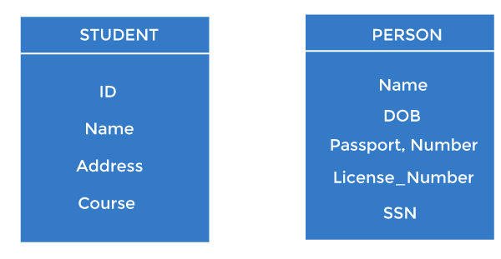

Types of keys:
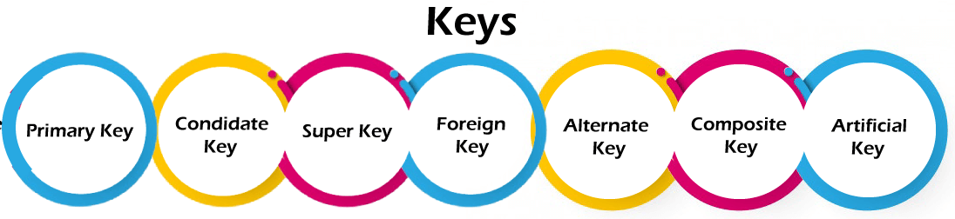

1. Primary key
- It is the first key used to identify one and only one instance of an entity uniquely. An entity can contain multiple keys, as we saw in the PERSON table. The key which is most suitable from those lists becomes a primary key.
- In the EMPLOYEE table, ID can be the primary key since it is unique for each employee. In the EMPLOYEE table, we can even select License_Number and Passport_Number as primary keys since they are also unique.
- For each entity, the primary key selection is based on requirements and developers.
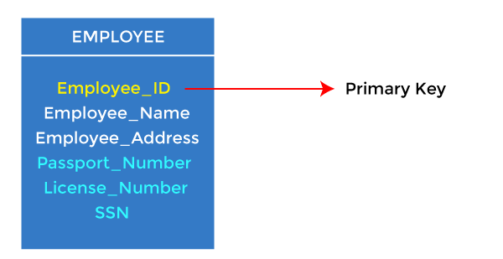

2. Candidate key
- A candidate key is an attribute or set of attributes that can uniquely identify a tuple.
- Except for the primary key, the remaining attributes are considered a candidate key. The candidate keys are as strong as the primary key.
For example: In the EMPLOYEE table, id is best suited for the primary key. The rest of the attributes, like SSN, Passport_Number, License_Number, etc., are considered a candidate key.
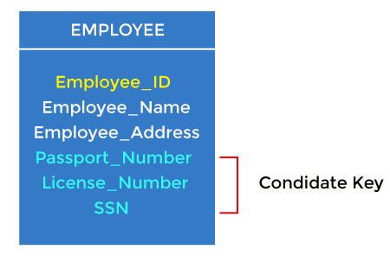

3. Super Key
Super key is an attribute set that can uniquely identify a tuple. A super key is a superset of a candidate key.
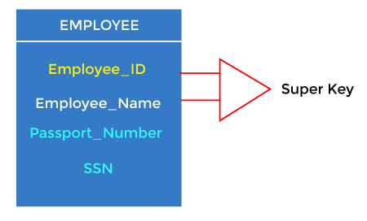
For example: In the above EMPLOYEE table, for(EMPLOEE_ID, EMPLOYEE_NAME), the name of two employees can be the same, but their EMPLYEE_ID can't be the same. Hence, this combination can also be a key.
The super key would be EMPLOYEE-ID (EMPLOYEE_ID, EMPLOYEE-NAME), etc.

4. Foreign key
- Foreign keys are the column of the table used to point to the primary key of another table.
- Every employee works in a specific department in a company, and employee and department are two different entities. So we can't store the department's information in the employee table. That's why we link these two tables through the primary key of one table.
- We add the primary key of the DEPARTMENT table, Department_Id, as a new attribute in the EMPLOYEE table.
- In the EMPLOYEE table, Department_Id is the foreign key, and both the tables are related.
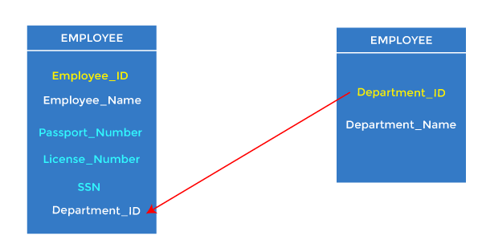

5. Alternate key
There may be one or more attributes or a combination of attributes that uniquely identify each tuple in a relation. These attributes or combinations of the attributes are called the candidate keys. One key is chosen as the primary key from these candidate keys, and the remaining candidate key, if it exists, is termed the alternate key. In other words, the total number of the alternate keys is the total number of candidate keys minus the primary key. The alternate key may or may not exist. If there is only one candidate key in a relation, it does not have an alternate key.
For example, employee relation has two attributes, Employee_Id and PAN_No, that act as candidate keys. In this relation, Employee_Id is chosen as the primary key, so the other candidate key, PAN_No, acts as the Alternate key.
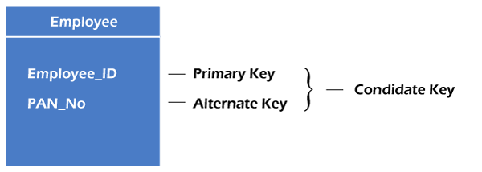

6. Composite key
Whenever a primary key consists of more than one attribute, it is known as a composite key. This key is also known as Concatenated Key.
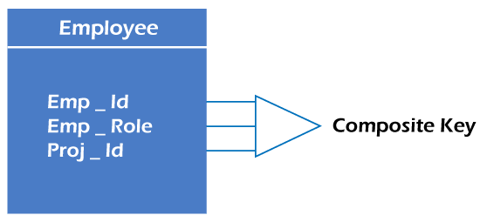
For example, in employee relations, we assume that an employee may be assigned multiple roles, and an employee may work on multiple projects simultaneously. So the primary key will be composed of all three attributes, namely Emp_ID, Emp_role, and Proj_ID in combination. So these attributes act as a composite key since the primary key comprises more than one attribute.
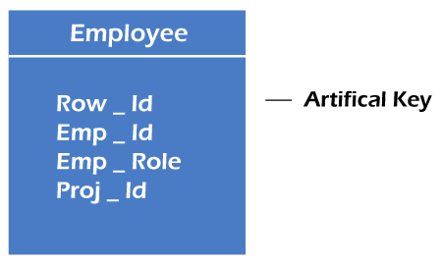

7. Artificial key
The key created using arbitrarily assigned data are known as artificial keys. These keys are created when a primary key is large and complex and has no relationship with many other relations. The data values of the artificial keys are usually numbered in a serial order.
For example, the primary key, which is composed of Emp_ID, Emp_role, and Proj_ID, is large in employee relations. So it would be better to add a new virtual attribute to identify each tuple in the relation uniquely.

Normalization
A large database defined as a single relation may result in data duplication. This repetition of data may result in:
- Making relations very large.
- It isn't easy to maintain and update data as it would involve searching many records in relation.
- Wastage and poor utilization of disk space and resources.
- The likelihood of errors and inconsistencies increases.
So to handle these problems, we should analyze and decompose the relations with redundant data into smaller, simpler, and well-structured relations that are satisfy desirable properties. Normalization is a process of decomposing the relations into relations with fewer attributes.

What is Normalization?
- Normalization is the process of organizing the data in the database.
- Normalization is used to minimize the redundancy from a relation or set of relations. It is also used to eliminate undesirable characteristics like Insertion, Update, and Deletion Anomalies.
- Normalization divides the larger table into smaller and links them using relationships.
- The normal form is used to reduce redundancy from the database table.
Why do we need Normalization?
The main reason for normalizing the relations is removing these anomalies. Failure to eliminate anomalies leads to data redundancy and can cause data integrity and other problems as the database grows. Normalization consists of a series of guidelines that helps to guide you in creating a good database structure.
Data modification anomalies can be categorized into three types:
- Insertion Anomaly: Insertion Anomaly refers to when one cannot insert a new tuple into a relationship due to lack of data.
- Deletion Anomaly: The delete anomaly refers to the situation where the deletion of data results in the unintended loss of some other important data.
- Updatation Anomaly: The update anomaly is when an update of a single data value requires multiple rows of data to be updated.

Types of Normal Forms:
Normalization works through a series of stages called Normal forms. The normal forms apply to individual relations. The relation is said to be in particular normal form if it satisfies constraints.
Following are the various types of Normal forms:
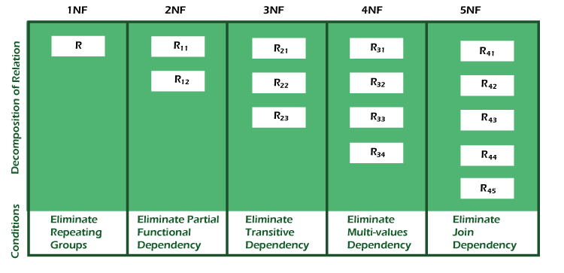
Normal Form | Description
1NF | A relation is in 1NF if it contains an atomic value.
2NF | A relation will be in 2NF if it is in 1NF and all non-key attributes are fully functional dependent on the primary key.
3NF | A relation will be in 3NF if it is in 2NF and no transition dependency exists.
BCNF | A stronger definition of 3NF is known as Boyce Codd's normal form.
4NF | A relation will be in 4NF if it is in Boyce Codd's normal form and has no multi-valued dependency.
5NF | A relation is in 5NF. If it is in 4NF and does not contain any join dependency, joining should be lossless.

Advantages of Normalization
- Normalization helps to minimize data redundancy.
- Greater overall database organization.
- Data consistency within the database.
- Much more flexible database design.
- Enforces the concept of relational integrity.

Disadvantages of Normalization
- You cannot start building the database before knowing what the user needs.
- The performance degrades when normalizing the relations to higher normal forms, i.e., 4NF, 5NF.
- It is very time-consuming and difficult to normalize relations of a higher degree.
- Careless decomposition may lead to a bad database design, leading to serious problems

First Normal Form (1NF)
- A relation will be 1NF if it contains an atomic value.
- It states that an attribute of a table cannot hold multiple values. It must hold only single-valued attribute.
- First normal form disallows the multi-valued attribute, composite attribute, and their combinations.
Example: Relation EMPLOYEE is not in 1NF because of multi-valued attribute EMP_PHONE.
EMPLOYEE table:
EMP_ID | EMP_NAME | EMP_PHONE | EMP_STATE
14 | John | 7272826385,  9064738238 | UP
20 | Harry | 8574783832 | Bihar
12 | Sam | 7390372389,  8589830302 | Punjab
The decomposition of the EMPLOYEE table into 1NF has been shown below:
EMP_ID | EMP_NAME | EMP_PHONE | EMP_STATE
14 | John | 7272826385 | UP
14 | John | 9064738238 | UP
20 | Harry | 8574783832 | Bihar
12 | Sam | 7390372389 | Punjab
12 | Sam | 8589830302 | Punjab

Second Normal Form (2NF)
- In the 2NF, relational must be in 1NF.
- In the second normal form, all non-key attributes are fully functional dependent on the primary key
Example: Let's assume, a school can store the data of teachers and the subjects they teach. In a school, a teacher can teach more than one subject.
TEACHER table
TEACHER_ID | SUBJECT | TEACHER_AGE
25 | Chemistry | 30
25 | Biology | 30
47 | English | 35
83 | Math | 38
83 | Computer | 38
In the given table, non-prime attribute TEACHER_AGE is dependent on TEACHER_ID which is a proper subset of a candidate key. That's why it violates the rule for 2NF.
To convert the given table into 2NF, we decompose it into two tables:
TEACHER_DETAIL table:
TEACHER_ID | TEACHER_AGE
25 | 30
47 | 35
83 | 38
TEACHER_SUBJECT table:
TEACHER_ID | SUBJECT
25 | Chemistry
25 | Biology
47 | English
83 | Math
83 | Computer

Third Normal Form (3NF)
- A relation will be in 3NF if it is in 2NF and not contain any transitive partial dependency.
- 3NF is used to reduce the data duplication. It is also used to achieve the data integrity.
- If there is no transitive dependency for non-prime attributes, then the relation must be in third normal form.
A relation is in third normal form if it holds atleast one of the following conditions for every non-trivial function dependency X → Y.
- X is a super key.
- Y is a prime attribute, i.e., each element of Y is part of some candidate key.
Example:
EMPLOYEE_DETAIL table:
EMP_ID | EMP_NAME | EMP_ZIP | EMP_STATE | EMP_CITY
222 | Harry | 201010 | UP | Noida
333 | Stephan | 02228 | US | Boston
444 | Lan | 60007 | US | Chicago
555 | Katharine | 06389 | UK | Norwich
666 | John | 462007 | MP | Bhopal
Super key in the table above:
  - {EMP_ID}, {EMP_ID, EMP_NAME}, {EMP_ID, EMP_NAME, EMP_ZIP}....so on
Candidate key: {EMP_ID}
Non-prime attributes: In the given table, all attributes except EMP_ID are non-prime.
Here, EMP_STATE & EMP_CITY dependent on EMP_ZIP and EMP_ZIP dependent on EMP_ID. The non-prime attributes (EMP_STATE, EMP_CITY) transitively dependent on super key(EMP_ID). It violates the rule of third normal form.
That's why we need to move the EMP_CITY and EMP_STATE to the new <EMPLOYEE_ZIP> table, with EMP_ZIP as a Primary key.
EMPLOYEE table:
EMP_ID | EMP_NAME | EMP_ZIP
222 | Harry | 201010
333 | Stephan | 02228
444 | Lan | 60007
555 | Katharine | 06389
666 | John | 462007
EMPLOYEE_ZIP table:
EMP_ZIP | EMP_STATE | EMP_CITY
201010 | UP | Noida
02228 | US | Boston
60007 | US | Chicago
06389 | UK | Norwich
462007 | MP | Bhopal

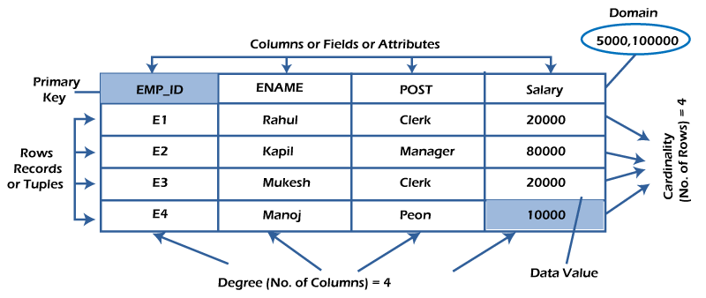

What is table/Relation?
Everything in a relational database is stored in the form of relations. The RDBMS database uses tables to store data. A table is a collection of related data entries and contains rows and columns to store data. Each table represents some real-world objects such as person, place, or event about which information is collected. The organized collection of data into a relational table is known as the logical view of the database.
Properties of a Relation:
- Each relation has a unique name by which it is identified in the database.
- Relation does not contain duplicate tuples.
- The tuples of a relation have no specific order.
- All attributes in a relation are atomic, i.e., each cell of a relation contains exactly one value.
A table is the simplest example of data stored in RDBMS.
Let's see the example of the student table.
ID | Name | AGE | COURSE
1 | Ajeet | 24 | B.Tech
2 | aryan | 20 | C.A
3 | Mahesh | 21 | BCA
4 | Ratan | 22 | MCA
5 | Vimal | 26 | BSC

What is a row or record?
A row of a table is also called a record or tuple. It contains the specific information of each entry in the table. It is a horizontal entity in the table. For example, The above table contains 5 records.
Properties of a row:
- No two tuples are identical to each other in all their entries.
- All tuples of the relation have the same format and the same number of entries.
- The order of the tuple is irrelevant. They are identified by their content, not by their position.
Let's see one record/row in the table.
ID | Name | AGE | COURSE
1 | Ajeet | 24 | B.Tech

What is a column/attribute?
A column is a vertical entity in the table which contains all information associated with a specific field in a table. For example, "name" is a column in the above table which contains all information about a student's name.
Properties of an Attribute:
- Every attribute of a relation must have a name.
- Null values are permitted for the attributes.
- Default values can be specified for an attribute automatically inserted if no other value is specified for an attribute.
- Attributes that uniquely identify each tuple of a relation are the primary key.
Name
Ajeet
Aryan
Mahesh
Ratan
Vimal

What is data item/Cells?
The smallest unit of data in the table is the individual data item. It is stored at the intersection of tuples and attributes.
Properties of data items:
- Data items are atomic.
- The data items for an attribute should be drawn from the same domain.
In the below example, the data item in the student table consists of Ajeet, 24 and Btech, etc.
ID | Name | AGE | COURSE
1 | Ajeet | 24 | B.Tech

Degree:
The total number of attributes that comprise a relation is known as the degree of the table.
For example, the student table has 4 attributes, and its degree is 4.
ID | Name | AGE | COURSE
1 | Ajeet | 24 | B.Tech
2 | aryan | 20 | C.A
3 | Mahesh | 21 | BCA
4 | Ratan | 22 | MCA
5 | Vimal | 26 | BSC

Cardinality:
The total number of tuples at any one time in a relation is known as the table's cardinality. The relation whose cardinality is 0 is called an empty table.
For example, the student table has 5 rows, and its cardinality is 5.
ID | Name | AGE | COURSE
1 | Ajeet | 24 | B.Tech
2 | aryan | 20 | C.A
3 | Mahesh | 21 | BCA
4 | Ratan | 22 | MCA
5 | Vimal | 26 | BSC

Domain:
The domain refers to the possible values each attribute can contain. It can be specified using standard data types such as integers, floating numbers, etc. For example, An attribute entitled Marital_Status may be limited to married or unmarried values.

NULL Values
The NULL value of the table specifies that the field has been left blank during record creation. It is different from the value filled with zero or a field that contains space.

Data Integrity
There are the following categories of data integrity exist with each RDBMS:
Entity integrity: It specifies that there should be no duplicate rows in a table.
Domain integrity: It enforces valid entries for a given column by restricting the type, the format, or the range of values.
Referential integrity specifies that rows cannot be deleted, which are used by other records.
User-defined integrity: It enforces some specific business rules defined by users. These rules are different from the entity, domain, or referential integrity.

SQL Commands
- SQL commands are instructions. It is used to communicate with the database. It is also used to perform specific tasks, functions, and queries of data.
- SQL can perform various tasks like create a table, add data to tables, drop the table, modify the table, set permission for users.

Types of SQL Commands
There are five types of SQL commands: DDL, DML, DCL, TCL, and DQL.
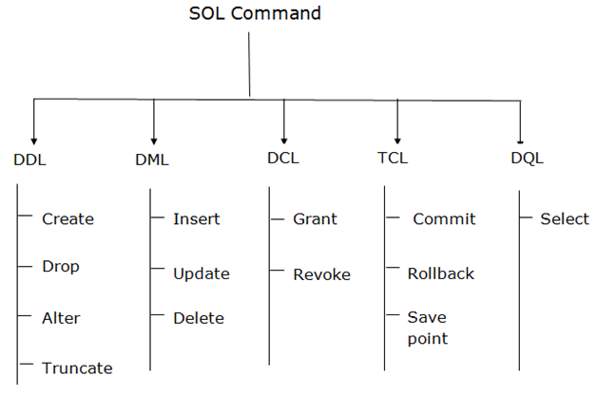

1. Data Definition Language (DDL)
- DDL changes the structure of the table like creating a table, deleting a table, altering a table, etc.
- All the command of DDL are auto-committed that means it permanently save all the changes in the database.
Here are some commands that come under DDL:
- CREATE
- ALTER
- DROP
- TRUNCATE
a. CREATE It is used to create a new table in the database.
Syntax:
- CREATE TABLE TABLE_NAME (COLUMN_NAME DATATYPES[,....]);
Example:
- CREATE TABLE EMPLOYEE(Name VARCHAR2(20), Email VARCHAR2(100), DOB DATE);
b. DROP: It is used to delete both the structure and record stored in the table.
Syntax
- DROP TABLE table_name;
Example
- DROP TABLE EMPLOYEE;
c. ALTER: It is used to alter the structure of the database. This change could be either to modify the characteristics of an existing attribute or probably to add a new attribute.
Syntax:
To add a new column in the table
- ALTER TABLE table_name ADD column_name COLUMN-definition;
To modify existing column in the table:
- ALTER TABLE table_name MODIFY(column_definitions....);
EXAMPLE
- ALTER TABLE STU_DETAILS ADD(ADDRESS VARCHAR2(20));
- ALTER TABLE STU_DETAILS MODIFY (NAME VARCHAR2(20));
d. TRUNCATE: It is used to delete all the rows from the table and free the space containing the table.
Syntax:
- TRUNCATE TABLE table_name;
Example:
- TRUNCATE TABLE EMPLOYEE;

2. Data Manipulation Language
- DML commands are used to modify the database. It is responsible for all form of changes in the database.
- The command of DML is not auto-committed that means it can't permanently save all the changes in the database. They can be rollback.
Here are some commands that come under DML:
- INSERT
- UPDATE
- DELETE
a. INSERT: The INSERT statement is a SQL query. It is used to insert data into the row of a table.
Syntax:
- INSERT INTO TABLE_NAME
- (col1, col2, col3,.... col N)
- VALUES (value1, value2, value3, .... valueN);
Or
- INSERT INTO TABLE_NAME
- VALUES (value1, value2, value3, .... valueN);
For example:
- INSERT INTO javatpoint (Author, Subject) VALUES ("Sonoo", "DBMS");
b. UPDATE: This command is used to update or modify the value of a column in the table.
Syntax:
- UPDATE table_name SET [column_name1= value1,...column_nameN = valueN] [WHERE CONDITION]
For example:
- UPDATE students
- SET User_Name = 'Sonoo'
- WHERE Student_Id = '3'
c. DELETE: It is used to remove one or more row from a table.
Syntax:
- DELETE FROM table_name [WHERE condition];
For example:
- DELETE FROM javatpoint
- WHERE Author="Sonoo";

3. Data Control Language
DCL commands are used to grant and take back authority from any database user.
Here are some commands that come under DCL:
- Grant
- Revoke
a. Grant: It is used to give user access privileges to a database.
Example
- GRANT SELECT, UPDATE ON MY_TABLE TO SOME_USER, ANOTHER_USER;
b. Revoke: It is used to take back permissions from the user.
Example
- REVOKE SELECT, UPDATE ON MY_TABLE FROM USER1, USER2;

4. Transaction Control Language
TCL commands can only use with DML commands like INSERT, DELETE and UPDATE only.
These operations are automatically committed in the database that's why they cannot be used while creating tables or dropping them.
Here are some commands that come under TCL:
- COMMIT
- ROLLBACK
- SAVEPOINT
a. Commit: Commit command is used to save all the transactions to the database.
Syntax:
- COMMIT;
Example:
- DELETE FROM CUSTOMERS
- WHERE AGE = 25;
- COMMIT;
b. Rollback: Rollback command is used to undo transactions that have not already been saved to the database.
Syntax:
- ROLLBACK;
Example:
- DELETE FROM CUSTOMERS
- WHERE AGE = 25;
- ROLLBACK;
c. SAVEPOINT: It is used to roll the transaction back to a certain point without rolling back the entire transaction.
Syntax:
- SAVEPOINT SAVEPOINT_NAME;

5. Data Query Language
DQL is used to fetch the data from the database.
It uses only one command:
- SELECT
a. SELECT: This is the same as the projection operation of relational algebra. It is used to select the attribute based on the condition described by WHERE clause.
Syntax:
- SELECT expressions
- FROM TABLES
- WHERE conditions;
For example:
- SELECT emp_name
- FROM employee
- WHERE age > 20;

Structured Query Language (SQL)
• Read
• Discuss
• Courses

Structured Query Language is a standard Database language that is used to create, maintain, and retrieve the relational database. In this article, we will discuss this in detail about SQL. Following are some interesting facts about SQL. Let’s focus on that.
SQL is case insensitive. But it is a recommended practice to use keywords (like SELECT, UPDATE, CREATE, etc.) in capital letters and use user-defined things (like table name, column name, etc.) in small letters.
We can write comments in SQL using “–” (double hyphen) at the beginning of any line. SQL is the programming language for relational databases (explained below) like MySQL, Oracle, Sybase, SQL Server, Postgre, etc. Other non-relational databases (also called NoSQL) databases like MongoDB, DynamoDB, etc. do not use SQL.
Although there is an ISO standard for SQL, most of the implementations slightly vary in syntax. So we may encounter queries that work in SQL Server but do not work in MySQL.

What is Relational Database?
A relational database means the data is stored as well as retrieved in the form of relations (tables). Table 1 shows the relational database with only one relation called STUDENT which stores ROLL_NO, NAME, ADDRESS, PHONE, and AGE of students.
STUDENT Table
ROLL_NO | NAME | ADDRESS | PHONE | AGE
1 | RAM | DELHI | 9455123451 | 18
2 | RAMESH | GURGAON | 9652431543 | 18
3 | SUJIT | ROHTAK | 9156253131 | 20
4 | SURESH | DELHI | 9156768971 | 18

Important Terminologies
These are some important terminologies that are used in terms of relation.
- Attribute:Attributes are the properties that define a relation. e.g.; ROLL_NO, NAME etc.
- Tuple:Each row in the relation is known as tuple. The above relation contains 4 tuples, one of which is shown as:
1 | RAM | DELHI | 9455123451 | 18
- Degree:The number of attributes in the relation is known as degree of the relation. The STUDENT relation defined above has degree 5.
- Cardinality:The number of tuples in a relation is known as cardinality. The STUDENTrelation defined above has cardinality 4.
- Column:Column represents the set of values for a particular attribute. The column ROLL_NO is extracted from relation STUDENT.
ROLL_NO
1
2
3
4

How Queries can be Categorized in Relational Database?
The queries to deal with relational database can be categories as:
- Data Definition Language:It is used to define the structure of the database. e.g; CREATE TABLE, ADD COLUMN, DROP COLUMN and so on.
- Data Manipulation Language:It is used to manipulate data in the relations. e.g.; INSERT, DELETE, UPDATE and so on.
- Data Query Language:It is used to extract the data from the relations. e.g.; SELECT So first we will consider the Data Query Language. A generic query to retrieve from a relational database is:
- SELECT [DISTINCT] Attribute_List FROM R1,R2….RM
- [WHERE condition]
- [GROUP BY (Attributes)[HAVING condition]]
- [ORDER BY(Attributes)[DESC]];
Part of the query represented by statement 1 is compulsory if you want to retrieve from a relational database. The statements written inside [] are optional. We will look at the possible query combination on relation shown in Table 1.

Different Query Combinations
Case 1: If we want to retrieve attributes ROLL_NO and NAMEof all students, the query will be:
SELECT ROLL_NO, NAME FROM STUDENT;
ROLL_NO | NAME
1 | RAM
2 | RAMESH
3 | SUJIT
4 | SURESH
Case 2: If we want to retrieve ROLL_NO and NAME of the students whose ROLL_NO is greater than 2, the query will be:
SELECT ROLL_NO, NAME FROM STUDENT
WHERE ROLL_NO>2;
ROLL_NO | NAME
3 | SUJIT
4 | SURESH
CASE 3: If we want to retrieve all attributes of students, we can write * in place of writing all attributes as:
SELECT * FROM STUDENT
WHERE ROLL_NO>2;
ROLL_NO | NAME | ADDRESS | PHONE | AGE
3 | SUJIT | ROHTAK | 9156253131 | 20
4 | SURESH | DELHI | 9156768971 | 18
CASE 4: If we want to represent the relation in ascending order by AGE, we can use ORDER BY clause as:
SELECT * FROM STUDENT ORDER BY AGE;
ROLL_NO | NAME | ADDRESS | PHONE | AGE
1 | RAM | DELHI | 9455123451 | 18
2 | RAMESH | GURGAON | 9652431543 | 18
4 | SURESH | DELHI | 9156768971 | 18
3 | SUJIT | ROHTAK | 9156253131 | 20
Note:
ORDER BY AGEis equivalent to ORDER BY AGE ASC.
If we want to retrieve the results in descending order of AGE, we can use ORDER BY AGE DESC.
CASE 5: If we want to retrieve distinct values of an attribute or group of attribute, DISTINCT is used as in:
SELECT DISTINCT ADDRESS FROM STUDENT;
ADDRESS
DELHI
GURGAON
ROHTAK
If DISTINCT is not used, DELHI will be repeated twice in result set. Before understanding GROUP BY and HAVING, we need to understand aggregations functions in SQL.

Aggregation Functions
Aggregation functions are used to perform mathematical operations on data values of a relation. Some of the common aggregation functions used in SQL are:
- COUNT: Count function is used to count the number of rows in a relation. e.g;
SELECT COUNT (PHONE) FROM STUDENT;
COUNT(PHONE)
4
- SUM: SUM function is used to add the values of an attribute in a relation. e.g;
SELECT SUM(AGE) FROM STUDENT;
SUM(AGE)
74
In the same way, MIN, MAX and AVG can be used. As we have seen above, all aggregation functions return only 1 row. AVERAGE: It gives the average values of the tupples. It is also defined as sum divided by count values.
Syntax:
AVG(attributename)
OR
SUM(attributename)/COUNT(attributename)
The above mentioned syntax also retrieves the average value of tupples.
- MAXIMUM:It extracts the maximum value among the set of tupples.
Syntax:
MAX(attributename)
- MINIMUM:It extracts the minimum value amongst the set of all the tupples.
Syntax:
MIN(attributename)
- GROUP BY:Group by is used to group the tuples of a relation based on an attribute or group of attribute. It is always combined with aggregation function which is computed on group. e.g.;
SELECT ADDRESS, SUM(AGE) FROM STUDENT
GROUP BY (ADDRESS);
In this query, SUM(AGE) will be computed but not for entire table but for each address. i.e.; sum of AGE for address DELHI(18+18=36) and similarly for other address as well. The output is:
ADDRESS | SUM(AGE)
DELHI | 36
GURGAON | 18
ROHTAK | 20
If we try to execute the query given below, it will result in error because although we have computed SUM(AGE) for each address, there are more than 1 ROLL_NO for each address we have grouped. So it can’t be displayed in result set. We need to use aggregate functions on columns after SELECT statement to make sense of the resulting set whenever we are using GROUP BY.
SELECT ROLL_NO, ADDRESS, SUM(AGE) FROM STUDENT
GROUP BY (ADDRESS);
NOTE:
An attribute which is not a part of GROUP BY clause can’t be used for selection.
Any attribute which is part of GROUP BY CLAUSE can be used for selection but it is not mandatory.
But we could use attributes which are not a part of the GROUP BY clause in an aggregate function.

Conclusion
SQL is a standard language used to manage data in relational databases. SQL is mainly divided into four main categories: Data definition language, data manipulation language, transaction control language, and data query language and SQL is a powerful language that can be used to carry out a wide range of operations like insert ,delete and update.

Integrity Constraints
- Integrity constraints are a set of rules. It is used to maintain the quality of information.
- Integrity constraints ensure that the data insertion, updating, and other processes have to be performed in such a way that data integrity is not affected.
- Thus, integrity constraint is used to guard against accidental damage to the database.

Types of Integrity Constraint
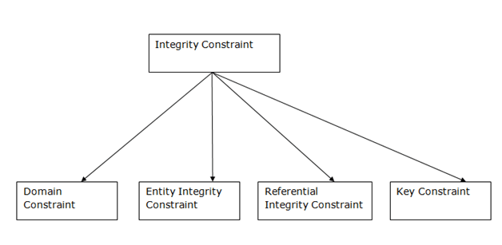

1. Domain constraints
- Domain constraints can be defined as the definition of a valid set of values for an attribute.
- The data type of domain includes string, character, integer, time, date, currency, etc. The value of the attribute must be available in the corresponding domain.
Example:
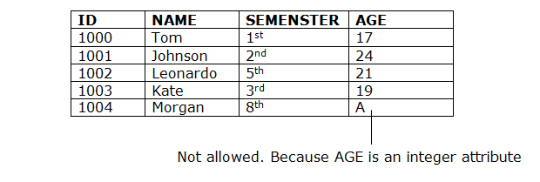

2. Entity integrity constraints
- The entity integrity constraint states that primary key value can't be null.
- This is because the primary key value is used to identify individual rows in relation and if the primary key has a null value, then we can't identify those rows.
- A table can contain a null value other than the primary key field.
Example:
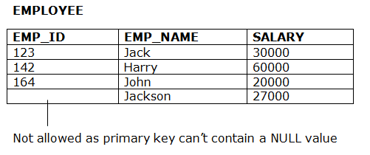

3. Referential Integrity Constraints
- A referential integrity constraint is specified between two tables.
- In the Referential integrity constraints, if a foreign key in Table 1 refers to the Primary Key of Table 2, then every value of the Foreign Key in Table 1 must be null or be available in Table 2.
Example:
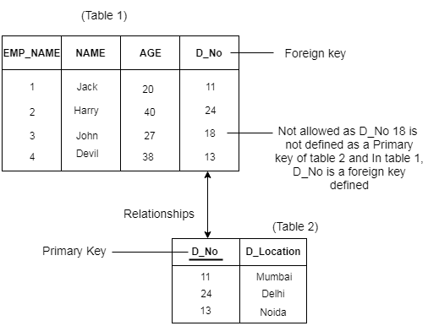

4. Key constraints
- Keys are the entity set that is used to identify an entity within its entity set uniquely.
- An entity set can have multiple keys, but out of which one key will be the primary key. A primary key can contain a unique and null value in the relational table.
Example:

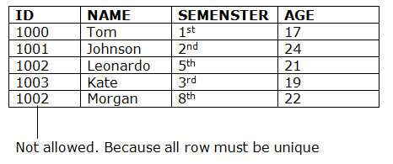 SQL | Constraints


harsh.agarwal0

• Read
• Discuss
• Courses
• Practice
• Video

Constraints are the rules that we can apply on the type of data in a table. That is, we can specify the limit on the type of data that can be stored in a particular column in a table using constraints.
The available constraints in SQL are:
- NOT NULL: This constraint tells that we cannot store a null value in a column. That is, if a column is specified as NOT NULL then we will not be able to store null in this particular column any more.
- UNIQUE: This constraint when specified with a column, tells that all the values in the column must be unique. That is, the values in any row of a column must not be repeated.
- PRIMARY KEY: A primary key is a field which can uniquely identify each row in a table. And this constraint is used to specify a field in a table as primary key.
- FOREIGN KEY: A Foreign key is a field which can uniquely identify each row in a another table. And this constraint is used to specify a field as Foreign key.
- CHECK: This constraint helps to validate the values of a column to meet a particular condition. That is, it helps to ensure that the value stored in a column meets a specific condition.
- DEFAULT: This constraint specifies a default value for the column when no value is specified by the user.
How to specify constraints?
We can specify constraints at the time of creating the table using CREATE TABLE statement. We can also specify the constraints after creating a table using ALTER TABLE statement.
Syntax:
Below is the syntax to create constraints using CREATE TABLE statement at the time of creating the table.
CREATE TABLE sample_table
(
column1 data_type(size) constraint_name,
column2 data_type(size) constraint_name,
column3 data_type(size) constraint_name,
....
);

sample_table: Name of the table to be created.
data_type: Type of data that can be stored in the field.
constraint_name: Name of the constraint. for example- NOT NULL, UNIQUE, PRIMARY KEY etc.
Let us see each of the constraint in detail.
1. NOT NULL –
If we specify a field in a table to be NOT NULL. Then the field will never accept null value. That is, you will be not allowed to insert a new row in the table without specifying any value to this field.
For example, the below query creates a table Student with the fields ID and NAME as NOT NULL. That is, we are bound to specify values for these two fields every time we wish to insert a new row.
CREATE TABLE Student
(
ID int(6) NOT NULL,
NAME varchar(10) NOT NULL,
ADDRESS varchar(20)
);
2. UNIQUE –
This constraint helps to uniquely identify each row in the table. i.e. for a particular column, all the rows should have unique values. We can have more than one UNIQUE columns in a table.
For example, the below query creates a table Student where the field ID is specified as UNIQUE. i.e, no two students can have the same ID. Unique constraint in detail.
CREATE TABLE Student
(
ID int(6) NOT NULL UNIQUE,
NAME varchar(10),
ADDRESS varchar(20)
);
3. PRIMARY KEY –
Primary Key is a field which uniquely identifies each row in the table. If a field in a table as primary key, then the field will not be able to contain NULL values as well as all the rows should have unique values for this field. So, in other words we can say that this is combination of NOT NULL and UNIQUE constraints.
A table can have only one field as primary key. Below query will create a table named Student and specifies the field ID as primary key.
CREATE TABLE Student
(
ID int(6) NOT NULL UNIQUE,
NAME varchar(10),
ADDRESS varchar(20),
PRIMARY KEY(ID)
);
4. FOREIGN KEY –
Foreign Key is a field in a table which uniquely identifies each row of a another table. That is, this field points to primary key of another table. This usually creates a kind of link between the tables.
Consider the two tables as shown below:
Orders

O_ID | ORDER_NO | C_ID
1 | 2253 | 3
2 | 3325 | 3
3 | 4521 | 2
4 | 8532 | 1

Customers

C_ID | NAME | ADDRESS
1 | RAMESH | DELHI
2 | SURESH | NOIDA
3 | DHARMESH | GURGAON
As we can see clearly that the field C_ID in Orders table is the primary key in Customers table, i.e. it uniquely identifies each row in the Customers table. Therefore, it is a Foreign Key in Orders table.
Syntax:
CREATE TABLE Orders
(
O_ID int NOT NULL,
ORDER_NO int NOT NULL,
C_ID int,
PRIMARY KEY (O_ID),
FOREIGN KEY (C_ID) REFERENCES Customers(C_ID)
)
(i) CHECK –
Using the CHECK constraint we can specify a condition for a field, which should be satisfied at the time of entering values for this field.
For example, the below query creates a table Student and specifies the condition for the field AGE as (AGE >= 18 ). That is, the user will not be allowed to enter any record in the table with AGE < 18. Check constraint in detail
CREATE TABLE Student
(
ID int(6) NOT NULL,
NAME varchar(10) NOT NULL,
AGE int NOT NULL CHECK (AGE >= 18)
);
(ii) DEFAULT –
This constraint is used to provide a default value for the fields. That is, if at the time of entering new records in the table if the user does not specify any value for these fields then the default value will be assigned to them.
For example, the below query will create a table named Student and specify the default value for the field AGE as 18.
CREATE TABLE Student
(
ID int(6) NOT NULL,
NAME varchar(10) NOT NULL,
AGE int DEFAULT 18
);
This article is contributed by Harsh Agarwal. If you like GeeksforGeeks and would like to contribute, you can also write an article using write.geeksforgeeks.org or mail your article to review-team@geeksforgeeks.org. See your article appearing on the GeeksforGeeks main page and help other Geeks.
Please write comments if you find anything incorrect, or you want to share more information about the topic discussed above.
If you like GeeksforGeeks and would like to contribute, you can also write an article and mail your article to review-team@geeksforgeeks.org. See your article appearing on the GeeksforGeeks main page and help other Geeks.
Please write comments if you find anything incorrect, or you want to share more information about the topic discussed above

SQL Operators
Every database administrator and user uses SQL queries for manipulating and accessing the data of database tables and views.
The manipulation and retrieving of the data are performed with the help of reserved words and characters, which are used to perform arithmetic operations, logical operations, comparison operations, compound operations, etc.

What is SQL Operator?
The SQL reserved words and characters are called operators, which are used with a WHERE clause in a SQL query. In SQL, an operator can either be a unary or binary operator. The unary operator uses only one operand for performing the unary operation, whereas the binary operator uses two operands for performing the binary operation.
Syntax of Unary SQL Operator
- Operator SQL_Operand
Syntax of Unary SQL Operator
- Operand1 SQL_Operator Operand2

Note: SQL operators are used for filtering the table's data by a specific condition in the SQL statement.

What is the Precedence of SQL Operator?
The precedence of SQL operators is the sequence in which the SQL evaluates the different operators in the same expression. Structured Query Language evaluates those operators first, which have high precedence.
In the following table, the operators at the top have high precedence, and the operators that appear at the bottom have low precedence.
SQL Operator Symbols | Operators
** | Exponentiation operator
+, - | Identity operator, Negation operator
*, / | Multiplication operator, Division operator
+, -, || | Addition (plus) operator, subtraction (minus) operator, String Concatenation operator
=, !=, <, >, <=, >=, IS NULL, LIKE, BETWEEN, IN | Comparison Operators
NOT | Logical negation operator
&& or AND | Conjunction operator
OR | Inclusion operator
For Example,
- UPDATE employee
- SET salary = 20 - 3 * 5 WHERE Emp_Id = 5;
In the above SQL example, salary is assigned 5, not 85, because the * (Multiplication)
Operator has higher precedence than the - (subtraction) operator, so it first gets multiplied with 3*5 and then subtracts from 20.

Types of Operator
SQL operators are categorized in the following categories:
- SQL Arithmetic Operators
- SQL Comparison Operators
- SQL Logical Operators
- SQL Set Operators
- SQL Bit-wise Operators
- SQL Unary Operators
Let's discuss each operator with their types.

SQL Arithmetic Operators
The Arithmetic Operators perform the mathematical operation on the numerical data of the SQL tables. These operators perform addition, subtraction, multiplication, and division operations on the numerical operands.
Following are the various arithmetic operators performed on the SQL data:
- SQL Addition Operator (+)
- SQL Subtraction Operator (-)
- SQL Multiplication Operator (+)
- SQL Division Operator (-)
- SQL Modulus Operator (+)

SQL Addition Operator (+)
The Addition Operator in SQL performs the addition on the numerical data of the database table. In SQL, we can easily add the numerical values of two columns of the same table by specifying both the column names as the first and second operand. We can also add the numbers to the existing numbers of the specific column.
Syntax of SQL Addition Operator:
- SELECT operand1 + operand2;
Let's understand the below example which explains how to execute Addition Operator in SQL query:
This example consists of an Employee_details table, which has four columns Emp_Id, Emp_Name, Emp_Salary, and Emp_Monthlybonus.
Emp Id | Emp Name | Emp Salary | Emp Monthlybonus
101 | Tushar | 25000 | 4000
102 | Anuj | 30000 | 200
- Suppose, we want to add 20,000 to the salary of each employee specified in the table. Then, we have to write the following query in the SQL:
- SELECT Emp_Salary + 20000 as Emp_New_Salary FROM Employee_details;
In this query, we have performed the SQL addition operation on the single column of the given table.
- Suppose, we want to add the Salary and monthly bonus columns of the above table, then we have to write the following query in SQL:
- SELECT Emp_Salary + Emp_Monthlybonus as Emp_Total_Salary FROM Employee_details;
In this query, we have added two columns with each other of the above table.

SQL Subtraction Operator (-)
The Subtraction Operator in SQL performs the subtraction on the numerical data of the database table. In SQL, we can easily subtract the numerical values of two columns of the same table by specifying both the column names as the first and second operand. We can also subtract the number from the existing number of the specific table column.
Syntax of SQL Subtraction Operator:
- SELECT operand1 - operand2;
Let's understand the below example which explains how to execute Subtraction Operator in SQL query:
This example consists of an Employee_details table, which has four columns Emp_Id, Emp_Name, Emp_Salary, and Emp_Monthlybonus.
Emp Id | Emp Name | Emp Salary | Penalty
201 | Abhay | 25000 | 200
202 | Sumit | 30000 | 500
- Suppose we want to subtract 5,000 from the salary of each employee given in the Employee_details table. Then, we have to write the following query in the SQL:
- SELECT Emp_Salary - 5000 as Emp_New_Salary FROM Employee_details;
In this query, we have performed the SQL subtraction operation on the single column of the given table.
- If we want to subtract the penalty from the salary of each employee, then we have to write the following query in SQL:
- SELECT Emp_Salary - Penalty as Emp_Total_Salary FROM Employee_details;

SQL Multiplication Operator (*)
The Multiplication Operator in SQL performs the Multiplication on the numerical data of the database table. In SQL, we can easily multiply the numerical values of two columns of the same table by specifying both the column names as the first and second operand.
Syntax of SQL Multiplication Operator:
- SELECT operand1 * operand2;
Let's understand the below example which explains how to execute Multiplication Operator in SQL query:
This example consists of an Employee_details table, which has four columns Emp_Id, Emp_Name, Emp_Salary, and Emp_Monthlybonus.
Emp Id | Emp Name | Emp Salary | Penalty
201 | Abhay | 25000 | 200
202 | Sumit | 30000 | 500
- Suppose, we want to double the salary of each employee given in the Employee_details table. Then, we have to write the following query in the SQL:
- SELECT Emp_Salary * 2 as Emp_New_Salary FROM Employee_details;
In this query, we have performed the SQL multiplication operation on the single column of the given table.
- If we want to multiply the Emp_Id column to Emp_Salary column of that employee whose Emp_Id is 202, then we have to write the following query in SQL:
- SELECT Emp_Id * Emp_Salary as Emp_Id * Emp_Salary FROM Employee_details WHERE Emp_Id = 202;
In this query, we have multiplied the values of two columns by using the WHERE clause.

SQL Division Operator (/)
The Division Operator in SQL divides the operand on the left side by the operand on the right side.
Syntax of SQL Division Operator:
- SELECT operand1 / operand2;
In SQL, we can also divide the numerical values of one column by another column of the same table by specifying both column names as the first and second operand.
We can also perform the division operation on the stored numbers in the column of the SQL table.
Let's understand the below example which explains how to execute Division Operator in SQL query:
This example consists of an Employee_details table, which has three columns Emp_Id, Emp_Name, and Emp_Salary.
Emp Id | Emp Name | Emp Salary
201 | Abhay | 25000
202 | Sumit | 30000
- Suppose, we want to half the salary of each employee given in the Employee_details table. For this operation, we have to write the following query in the SQL:
- SELECT Emp_Salary / 2 as Emp_New_Salary FROM Employee_details;
In this query, we have performed the SQL division operation on the single column of the given table.

SQL Modulus Operator (%)
The Modulus Operator in SQL provides the remainder when the operand on the left side is divided by the operand on the right side.
Syntax of SQL Modulus Operator:
- SELECT operand1 % operand2;
Let's understand the below example which explains how to execute Modulus Operator in SQL query:
This example consists of a Division table, which has three columns Number, First_operand, and Second_operand.
Number | First operand | Second operand
1 | 56 | 4
2 | 32 | 8
3 | 89 | 9
4 | 18 | 10
5 | 10 | 5
- If we want to get the remainder by dividing the numbers of First_operand column by the numbers of Second_operand column, then we have to write the following query in SQL:
- SELECT First_operand % Second_operand as Remainder FROM Employee_details;

SQL Comparison Operators
The Comparison Operators in SQL compare two different data of SQL table and check whether they are the same, greater, and lesser. The SQL comparison operators are used with the WHERE clause in the SQL queries
Following are the various comparison operators which are performed on the data stored in the SQL database tables:
- SQL Equal Operator (=)
- SQL Not Equal Operator (!=)
- SQL Greater Than Operator (>)
- SQL Greater Than Equals to Operator (>=)
- SQL Less Than Operator (<)\
- SQL Less Than Equals to Operator (<=)

SQL Equal Operator (=)
This operator is highly used in SQL queries. The Equal Operator in SQL shows only data that matches the specified value in the query.
This operator returns TRUE records from the database table if the value of both operands specified in the query is matched.
Let's understand the below example which explains how to execute Equal Operator in SQL query:
This example consists of an Employee_details table, which has three columns Emp_Id, Emp_Name, and Emp_Salary.
Emp Id | Emp Name | Emp Salary
201 | Abhay | 30000
202 | Ankit | 40000
203 | Bheem | 30000
204 | Ram | 29000
205 | Sumit | 30000
- Suppose, we want to access all the records of those employees from the Employee_details table whose salary is 30000. Then, we have to write the following query in the SQL database:
- SELECT * FROM Employee_details WHERE Emp_Salary = 30000;
In this example, we used the SQL equal operator with WHERE clause for getting the records of those employees whose salary is 30000.

SQL Equal Not Operator (!=)
The Equal Not Operator in SQL shows only those data that do not match the query's specified value.
This operator returns those records or rows from the database views and tables if the value of both operands specified in the query is not matched with each other.
Let's understand the below example which explains how to execute Equal Not Operator in SQL query:
This example consists of an Employee_details table, which has three columns Emp_Id, Emp_Name, and Emp_Salary.
Emp Id | Emp Name | Emp Salary
201 | Abhay | 45000
202 | Ankit | 45000
203 | Bheem | 30000
204 | Ram | 29000
205 | Sumit | 29000
- Suppose, we want to access all the records of those employees from the Employee_details table whose salary is not 45000. Then, we have to write the following query in the SQL database:
- SELECT * FROM Employee_details WHERE Emp_Salary != 45000;
In this example, we used the SQL equal not operator with WHERE clause for getting the records of those employees whose salary is not 45000.

SQL Greater Than Operator (>)
The Greater Than Operator in SQL shows only those data which are greater than the value of the right-hand operand.
Let's understand the below example which explains how to execute Greater ThanOperator (>) in SQL query:
This example consists of an Employee_details table, which has three columns Emp_Id, Emp_Name, and Emp_Salary.
Emp Id | Emp Name | Emp Salary
201 | Abhay | 45000
202 | Ankit | 45000
203 | Bheem | 30000
204 | Ram | 29000
205 | Sumit | 29000
- Suppose, we want to access all the records of those employees from the Employee_details table whose employee id is greater than 202. Then, we have to write the following query in the SQL database:
- SELECT * FROM Employee_details WHERE Emp_Id > 202;
Here, SQL greater than operator displays the records of those employees from the above table whose Employee Id is greater than 202.

SQL Greater Than Equals to Operator (>=)
The Greater Than Equals to Operator in SQL shows those data from the table which are greater than and equal to the value of the right-hand operand.
Let's understand the below example which explains how to execute greater than equals to the operator (>=) in SQL query:
This example consists of an Employee_details table, which has three columns Emp_Id, Emp_Name, and Emp_Salary.
Emp Id | Emp Name | Emp Salary
201 | Abhay | 45000
202 | Ankit | 45000
203 | Bheem | 30000
204 | Ram | 29000
205 | Sumit | 29000
- Suppose, we want to access all the records of those employees from the Employee_details table whose employee id is greater than and equals to 202. For this, we have to write the following query in the SQL database:
- SELECT * FROM Employee_details WHERE Emp_Id >= 202;
Here,'SQL greater than equals to operator' with WHERE clause displays the rows of those employees from the table whose Employee Id is greater than and equals to 202.

SQL Less Than Operator (<)
The Less Than Operator in SQL shows only those data from the database tables which are less than the value of the right-side operand.
This comparison operator checks that the left side operand is lesser than the right side operand. If the condition becomes true, then this operator in SQL displays the data which is less than the value of the right-side operand.
Let's understand the below example which explains how to execute less than operator (<) in SQL query:
This example consists of an Employee_details table, which has three columns Emp_Id, Emp_Name, and Emp_Salary.
Emp Id | Emp Name | Emp Salary
201 | Abhay | 45000
202 | Ankit | 45000
203 | Bheem | 30000
204 | Ram | 29000
205 | Sumit | 29000
- Suppose, we want to access all the records of those employees from the Employee_details table whose employee id is less than 204. For this, we have to write the following query in the SQL database:
- SELECT * FROM Employee_details WHERE Emp_Id < 204;
Here,SQL less than operator with WHERE clause displays the records of those employees from the above table whose Employee Id is less than 204.

SQL Less Than Equals to Operator (<=)
The Less Than Equals to Operator in SQL shows those data from the table which are lesser and equal to the value of the right-side operand.
This comparison operator checks that the left side operand is lesser and equal to the right side operand.
Let's understand the below example which explains how to execute less than equals to the operator (<=) in SQL query:
This example consists of an Employee_details table, which has three columns Emp_Id, Emp_Name, and Emp_Salary.
Emp Id | Emp Name | Emp Salary
201 | Abhay | 45000
202 | Ankit | 45000
203 | Bheem | 30000
204 | Ram | 29000
205 | Sumit | 29000
- Suppose, we want to access all the records of those employees from the Employee_details table whose employee id is less and equals 203. For this, we have to write the following query in the SQL database:
- SELECT * FROM Employee_details WHERE Emp_Id <= 203;
Here, SQL less than equals to the operator with WHERE clause displays the rows of those employees from the table whose Employee Id is less than and equals 202.

SQL Logical Operators
The Logical Operators in SQL perform the Boolean operations, which give two results True and False. These operators provide True value if both operands match the logical condition.
Following are the various logical operators which are performed on the data stored in the SQL database tables:
- SQL ALL operator
- SQL AND operator
- SQL OR operator
- SQL BETWEEN operator
- SQL IN operator
- SQL NOT operator
- SQL ANY operator
- SQL LIKE operator

SQL ALL Operator
The ALL operator in SQL compares the specified value to all the values of a column from the sub-query in the SQL database.
This operator is always used with the following statement:
- SELECT,
- HAVING, and
- WHERE.
Syntax of ALL operator:
- SELECT column_Name1, ...., column_NameN FROM table_Name WHERE column Comparison_operator ALL (SELECT column FROM tablename2)
Let's understand the below example which explains how to execute ALL logical operators in SQL query:
This example consists of an Employee_details table, which has three columns Emp_Id, Emp_Name, Emp_Salary, and Emp_City.
Emp Id | Emp Name | Emp Salary | Emp City
201 | Abhay | 25000 | Gurgaon
202 | Ankit | 45000 | Delhi
203 | Bheem | 30000 | Jaipur
204 | Ram | 29000 | Mumbai
205 | Sumit | 40000 | Kolkata
- If we want to access the employee id and employee names of those employees from the table whose salaries are greater than the salary of employees who lives in Jaipur city, then we have to type the following query in SQL.
- SELECT Emp_Id, Emp_Name FROM Employee_details WHERE Emp_Salary > ALL ( SELECT Emp_Salary FROM Employee_details WHERE Emp_City = Jaipur)
Here, we used the SQL ALL operator with greater than the operator.

SQL AND Operator
The AND operator in SQL would show the record from the database table if all the conditions separated by the AND operator evaluated to True. It is also known as the conjunctive operator and is used with the WHERE clause.
Syntax of AND operator:
- SELECT column1, ...., columnN FROM table_Name WHERE condition1 AND condition2 AND condition3 AND ....... AND conditionN;
Let's understand the below example which explains how to execute AND logical operator in SQL query:
This example consists of an Employee_details table, which has three columns Emp_Id, Emp_Name, Emp_Salary, and Emp_City.
Emp Id | Emp Name | Emp Salary | Emp City
201 | Abhay | 25000 | Delhi
202 | Ankit | 45000 | Chandigarh
203 | Bheem | 30000 | Delhi
204 | Ram | 25000 | Delhi
205 | Sumit | 40000 | Kolkata
- Suppose, we want to access all the records of those employees from the Employee_details table whose salary is 25000 and the city is Delhi. For this, we have to write the following query in SQL:
  - SELECT * FROM Employee_details WHERE Emp_Salary = 25000 OR Emp_City = 'Delhi';
Here,SQL AND operator with WHERE clause shows the record of employees whose salary is 25000 and the city is Delhi.

SQL OR Operator
The OR operator in SQL shows the record from the table if any of the conditions separated by the OR operator evaluates to True. It is also known as the conjunctive operator and is used with the WHERE clause.
Syntax of OR operator:
- SELECT column1, ...., columnN FROM table_Name WHERE condition1 OR condition2 OR condition3 OR ....... OR conditionN;
Let's understand the below example which explains how to execute OR logical operator in SQL query:
This example consists of an Employee_details table, which has three columns Emp_Id, Emp_Name, Emp_Salary, and Emp_City.
Emp Id | Emp Name | Emp Salary | Emp City
201 | Abhay | 25000 | Delhi
202 | Ankit | 45000 | Chandigarh
203 | Bheem | 30000 | Delhi
204 | Ram | 25000 | Delhi
205 | Sumit | 40000 | Kolkata
- If we want to access all the records of those employees from the Employee_details table whose salary is 25000 or the city is Delhi. For this, we have to write the following query in SQL:
- SELECT * FROM Employee_details WHERE Emp_Salary = 25000 OR Emp_City = 'Delhi';
Here, SQL OR operator with WHERE clause shows the record of employees whose salary is 25000 or the city is Delhi.

SQL BETWEEN Operator
The BETWEEN operator in SQL shows the record within the range mentioned in the SQL query. This operator operates on the numbers, characters, and date/time operands.
If there is no value in the given range, then this operator shows NULL value.
Syntax of BETWEEN operator:
- SELECT column_Name1, column_Name2 ...., column_NameN FROM table_Name WHERE column_nameBETWEEN value1 and value2;
Let's understand the below example which explains how to execute BETWEEN logical operator in SQL query:
This example consists of an Employee_details table, which has three columns Emp_Id, Emp_Name, Emp_Salary, and Emp_City.
Emp Id | Emp Name | Emp Salary | Emp City
201 | Abhay | 25000 | Delhi
202 | Ankit | 45000 | Chandigarh
203 | Bheem | 30000 | Delhi
204 | Ram | 25000 | Delhi
205 | Sumit | 40000 | Kolkata
- Suppose, we want to access all the information of those employees from the Employee_details table who is having salaries between 20000 and 40000. For this, we have to write the following query in SQL:
- SELECT * FROM Employee_details WHERE Emp_Salary BETWEEN 30000 AND 45000;
Here, we used the SQL BETWEEN operator with the Emp_Salary field.

SQL IN Operator
The IN operator in SQL allows database users to specify two or more values in a WHERE clause. This logical operator minimizes the requirement of multiple OR conditions.
This operator makes the query easier to learn and understand. This operator returns those rows whose values match with any value of the given list.
Syntax of IN operator:
- SELECT column_Name1, column_Name2 ...., column_NameN FROM table_Name WHERE column_name IN (list_of_values);
Let's understand the below example which explains how to execute IN logical operator in SQL query:
This example consists of an Employee_details table, which has three columns Emp_Id, Emp_Name, Emp_Salary, and Emp_City.
Emp Id | Emp Name | Emp Salary | Emp City
201 | Abhay | 25000 | Delhi
202 | Ankit | 45000 | Chandigarh
203 | Bheem | 30000 | Delhi
204 | Ram | 25000 | Delhi
205 | Sumit | 40000 | Kolkata
- Suppose, we want to show all the information of those employees from the Employee_details table whose Employee Id is 202, 204, and 205. For this, we have to write the following query in SQL:
- SELECT * FROM Employee_details WHERE Emp_Id IN (202, 204, 205);
Here, we used the SQL IN operator with the Emp_Id column.
- Suppose, we want to show all the information of those employees from the Employee_details table whose Employee Id is not equal to 202 and 205. For this, we have to write the following query in SQL:
- SELECT * FROM Employee_details WHERE Emp_Id NOT IN (202,205);

Here, we used the SQL NOT IN operator with the Emp_Id column.

SQL NOT Operator
The NOT operator in SQL shows the record from the table if the condition evaluates to false. It is always used with the WHERE clause.
Syntax of NOT operator:
- SELECT column1, column2 ...., columnN FROM table_Name WHERE NOT condition;
Let's understand the below example which explains how to execute NOT logical operator in SQL query:
This example consists of an Employee_details table, which has four columns Emp_Id, Emp_Name, Emp_Salary, and Emp_City.
Emp Id | Emp Name | Emp Salary | Emp City
201 | Abhay | 25000 | Delhi
202 | Ankit | 45000 | Chandigarh
203 | Bheem | 30000 | Delhi
204 | Ram | 25000 | Delhi
205 | Sumit | 40000 | Kolkata
- Suppose, we want to show all the information of those employees from the Employee_details table whose Cityis not Delhi. For this, we have to write the following query in SQL:
- SELECT * FROM Employee_details WHERE NOT Emp_City = 'Delhi' ;
In this example, we used the SQL NOT operator with the Emp_City column.
- Suppose, we want to show all the information of those employees from the Employee_details table whose Cityis not Delhi and Chandigarh. For this, we have to write the following query in SQL:
- SELECT * FROM Employee_details WHERE NOT Emp_City = 'Delhi' AND NOT Emp_City = 'Chandigarh';
In this example, we used the SQL NOT operator with the Emp_City column.

SQL ANY Operator
The ANY operator in SQL shows the records when any of the values returned by the sub-query meet the condition.
The ANY logical operator must match at least one record in the inner query and must be preceded by any SQL comparison operator.
Syntax of ANY operator:
- SELECT column1, column2 ...., columnN FROM table_Name WHERE column_name comparison_operator ANY ( SELECT column_name FROM table_name WHERE condition(s)) ;

SQL LIKE Operator
The LIKE operator in SQL shows those records from the table which match with the given pattern specified in the sub-query.
The percentage (%) sign is a wildcard which is used in conjunction with this logical operator.
This operator is used in the WHERE clause with the following three statements:
- SELECT statement
- UPDATE statement
- DELETE statement
Syntax of LIKE operator:
- SELECT column_Name1, column_Name2 ...., column_NameN FROM table_Name WHERE column_name LIKE pattern;
Let's understand the below example which explains how to execute LIKE logical operator in SQL query:
This example consists of an Employee_details table, which has four columns Emp_Id, Emp_Name, Emp_Salary, and Emp_City.
Emp Id | Emp Name | Emp Salary | Emp City
201 | Sanjay | 25000 | Delhi
202 | Ajay | 45000 | Chandigarh
203 | Saket | 30000 | Delhi
204 | Abhay | 25000 | Delhi
205 | Sumit | 40000 | Kolkata
- If we want to show all the information of those employees from the Employee_details whose name starts with ''s''. For this, we have to write the following query in SQL:
- SELECT * FROM Employee_details WHERE Emp_Name LIKE 's%' ;
In this example, we used the SQL LIKE operator with Emp_Name column because we want to access the record of those employees whose name starts with s.
- If we want to show all the information of those employees from the Employee_detailswhose name ends with ''y''. For this, we have to write the following query in SQL:
- SELECT * FROM Employee_details WHERE Emp_Name LIKE '%y' ;
- If we want to show all the information of those employees from the Employee_detailswhose name starts with ''S'' and ends with ''y''. For this, we have to write the following query in SQL:
- SELECT * FROM Employee_details WHERE Emp_Name LIKE 'S%y' ;

SQL Set Operators
The Set Operators in SQL combine a similar type of data from two or more SQL database tables. It mixes the result, which is extracted from two or more SQL queries, into a single result.
Set operators combine more than one select statement in a single query and return a specific result set.
Following are the various set operators which are performed on the similar data stored in the two SQL database tables:
- SQL Union Operator
- SQL Union ALL Operator
- SQL Intersect Operator
- SQL Minus Operator

SQL Union Operator
The SQL Union Operator combines the result of two or more SELECT statements and provides the single output.
The data type and the number of columns must be the same for each SELECT statement used with the UNION operator. This operator does not show the duplicate records in the output table.
Syntax of UNION Set operator:
- SELECT column1, column2 ...., columnN FROM table_Name1 [WHERE conditions]
- UNION
- SELECT column1, column2 ...., columnN FROM table_Name2 [WHERE conditions];
Let's understand the below example which explains how to execute Union operator in Structured Query Language:
In this example, we used two tables. Both tables have four columns Emp_Id, Emp_Name, Emp_Salary, and Emp_City.
Emp Id | Emp Name | Emp Salary | Emp City
201 | Sanjay | 25000 | Delhi
202 | Ajay | 45000 | Delhi
203 | Saket | 30000 | Aligarh
Table: Employee_details1
Emp Id | Emp Name | Emp Salary | Emp City
203 | Saket | 30000 | Aligarh
204 | Saurabh | 40000 | Delhi
205 | Ram | 30000 | Kerala
201 | Sanjay | 25000 | Delhi
Table: Employee_details2
- Suppose, we want to see the employee name and employee id of each employee from both tables in a single output. For this, we have to write the following query in SQL:
- SELECT Emp_ID, Emp_Name FROM Employee_details1
- UNION
- SELECT Emp_ID, Emp_Name FROM Employee_details2 ;

SQL Union ALL Operator
The SQL Union Operator is the same as the UNION operator, but the only difference is that it also shows the same record.
Syntax of UNION ALL Set operator:
- SELECT column1, column2 ...., columnN FROM table_Name1 [WHERE conditions]
- UNION ALL
- SELECT column1, column2 ...., columnN FROM table_Name2 [WHERE conditions];
Let's understand the below example which explains how to execute Union ALL operator in Structured Query Language:
In this example, we used two tables. Both tables have four columns Emp_Id, Emp_Name, Emp_Salary, and Emp_City.
Emp Id | Emp Name | Emp Salary | Emp City
201 | Sanjay | 25000 | Delhi
202 | Ajay | 45000 | Delhi
203 | Saket | 30000 | Aligarh
Table: Employee_details1
Emp Id | Emp Name | Emp Salary | Emp City
203 | Saket | 30000 | Aligarh
204 | Saurabh | 40000 | Delhi
205 | Ram | 30000 | Kerala
201 | Sanjay | 25000 | Delhi
Table: Employee_details2
- If we want to see the employee name of each employee of both tables in a single output. For this, we have to write the following query in SQL:
- SELECT Emp_Name FROM Employee_details1
- UNION ALL
- SELECT Emp_Name FROM Employee_details2 ;

SQL Intersect Operator
The SQL Intersect Operator shows the common record from two or more SELECT statements. The data type and the number of columns must be the same for each SELECT statement used with the INTERSECT operator.
Syntax of INTERSECT Set operator:
- SELECT column1, column2 ...., columnN FROM table_Name1 [WHERE conditions]
- INTERSECT
- SELECT column1, column2 ...., columnN FROM table_Name2 [WHERE conditions];
Let's understand the below example which explains how to execute INTERSECT operator in Structured Query Language:
In this example, we used two tables. Both tables have four columns Emp_Id, Emp_Name, Emp_Salary, and Emp_City.
Emp Id | Emp Name | Emp Salary | Emp City
201 | Sanjay | 25000 | Delhi
202 | Ajay | 45000 | Delhi
203 | Saket | 30000 | Aligarh
Table: Employee_details1
Emp Id | Emp Name | Emp Salary | Emp City
203 | Saket | 30000 | Aligarh
204 | Saurabh | 40000 | Delhi
205 | Ram | 30000 | Kerala
201 | Sanjay | 25000 | Delhi
Table: Employee_details2
Suppose, we want to see a common record of the employee from both the tables in a single output. For this, we have to write the following query in SQL:
- SELECT Emp_Name FROM Employee_details1
- INTERSECT
- SELECT Emp_Name FROM Employee_details2 ;

SQL Minus Operator
The SQL Minus Operator combines the result of two or more SELECT statements and shows only the results from the first data set.
Syntax of MINUS operator:
- SELECT column1, column2 ...., columnN FROM First_tablename [WHERE conditions]
- MINUS
- SELECT column1, column2 ...., columnN FROM Second_tablename [WHERE conditions];
Let's understand the below example which explains how to execute INTERSECT operator in Structured Query Language:
In this example, we used two tables. Both tables have four columns Emp_Id, Emp_Name, Emp_Salary, and Emp_City.
Emp Id | Emp Name | Emp Salary | Emp City
201 | Sanjay | 25000 | Delhi
202 | Ajay | 45000 | Delhi
203 | Saket | 30000 | Aligarh
Table: Employee_details1
Emp Id | Emp Name | Emp Salary | Emp City
203 | Saket | 30000 | Aligarh
204 | Saurabh | 40000 | Delhi
205 | Ram | 30000 | Kerala
201 | Sanjay | 25000 | Delhi
Table: Employee_details2
Suppose, we want to see the name of employees from the first result set after the combination of both tables. For this, we have to write the following query in SQL:
- SELECT Emp_Name FROM Employee_details1
- MINUS
- SELECT Emp_Name FROM Employee_details2 ;

SQL Unary Operators
The Unary Operators in SQL perform the unary operations on the single data of the SQL table, i.e., these operators operate only on one operand.
These types of operators can be easily operated on the numeric data value of the SQL table.
Following are the various unary operators which are performed on the numeric data stored in the SQL table:
- SQL Unary Positive Operator
- SQL Unary Negative Operator
- SQL Unary Bitwise NOT Operator

SQL Unary Positive Operator
The SQL Positive (+) operator makes the numeric value of the SQL table positive.
Syntax of Unary Positive Operator
- SELECT +(column1), +(column2) ...., +(columnN) FROM table_Name [WHERE conditions] ;
Let's understand the below example which explains how to execute a Positive unary operator on the data of SQL table:
This example consists of anEmployee_details table, which has four columns Emp_Id, Emp_Name, Emp_Salary, and Emp_City.
Emp Id | Emp Name | Emp Salary | Emp City
201 | Sanjay | 25000 | Delhi
202 | Ajay | 45000 | Chandigarh
203 | Saket | 30000 | Delhi
204 | Abhay | 25000 | Delhi
205 | Sumit | 40000 | Kolkata
- Suppose, we want to see the salary of each employee as positive from the Employee_details table. For this, we have to write the following query in SQL:
- SELECT +Emp_Salary Employee_details ;

SQL Unary Negative Operator
The SQL Negative (-) operator makes the numeric value of the SQL table negative.
Syntax of Unary Negative Operator
- SELECT -(column_Name1), -(column_Name2) ...., -(column_NameN) FROM table_Name [WHERE conditions] ;
Let's understand the below example which explains how to execute Negative unary operator on the data of SQL table:
This example consists of an Employee_details table, which has four columns Emp_Id, Emp_Name, Emp_Salary, and Emp_City.
Emp Id | Emp Name | Emp Salary | Emp City
201 | Sanjay | 25000 | Delhi
202 | Ajay | 45000 | Chandigarh
203 | Saket | 30000 | Delhi
204 | Abhay | 25000 | Delhi
205 | Sumit | 40000 | Kolkata
- Suppose, we want to see the salary of each employee as negative from the Employee_details table. For this, we have to write the following query in SQL:
- SELECT -Emp_Salary Employee_details ;
- Suppose, we want to see the salary of those employees as negative whose city is Kolkatain the Employee_details table. For this, we have to write the following query in SQL:
- SELECT -Emp_Salary Employee_details WHERE Emp_City = 'Kolkata';

SQL Bitwise NOT Operator
The SQL Bitwise NOT operator provides the one's complement of the single numeric operand. This operator turns each bit of numeric value. If the bit of any numerical value is 001100, then this operator turns these bits into 110011.
Syntax of Bitwise NOT Operator
- SELECT ~(column1), ~(column2) ...., ~(columnN) FROM table_Name [WHERE conditions] ;
Let's understand the below example which explains how to execute the Bitwise NOT operator on the data of SQL table:
This example consists of aStudent_details table, which has four columns Roll_No, Stu_Name, Stu_Marks, and Stu_City.
Emp Id | Stu Name | Stu Marks | Stu City
101 | Sanjay | 85 | Delhi
102 | Ajay | 97 | Chandigarh
103 | Saket | 45 | Delhi
104 | Abhay | 68 | Delhi
105 | Sumit | 60 | Kolkata
If we want to perform the Bitwise Not operator on the marks column of Student_details, we have to write the following query in SQL:
- SELECT ~Stu_Marks Employee_details ;

SQL Bitwise Operators
The Bitwise Operators in SQL perform the bit operations on the Integer values. To understand the performance of Bitwise operators, you just knew the basics of Boolean algebra.
Following are the two important logical operators which are performed on the data stored in the SQL database tables:
- Bitwise AND (&)
- Bitwise OR(|)

Bitwise AND (&)
The Bitwise AND operator performs the logical AND operation on the given Integer values. This operator checks each bit of a value with the corresponding bit of another value.
Syntax of Bitwise AND Operator
- SELECT column1 & column2 & .... & columnN FROM table_Name [WHERE conditions] ;
Let's understand the below example which explains how to execute Bitwise AND operator on the data of SQL table:
This example consists of the following table, which has two columns. Each column holds numerical values.
When we use the Bitwise AND operator in SQL, then SQL converts the values of both columns in binary format, and the AND operation is performed on the converted bits.
After that, SQL converts the resultant bits into user understandable format, i.e., decimal format.
Column1 | Column2
1 | 1
2 | 5
3 | 4
4 | 2
5 | 3
- Suppose, we want to perform the Bitwise AND operator between both the columns of the above table. For this, we have to write the following query in SQL:
- SELECT Column1 & Column2 From TABLE_AND ;

Bitwise OR (|)
The Bitwise OR operator performs the logical OR operation on the given Integer values. This operator checks each bit of a value with the corresponding bit of another value.
Syntax of Bitwise OR Operator
- SELECT column1 | column2 | .... | columnN FROM table_Name [WHERE conditions] ;
Let's understand the below example which explains how to execute Bitwise OR operator on the data of SQL table:
This example consists of a table that has two columns. Each column holds numerical values.
When we used the Bitwise OR operator in SQL, then SQL converts the values of both columns in binary format, and the OR operation is performed on the binary bits. After that, SQL converts the resultant binary bits into user understandable format, i.e., decimal format.
Column1 | Column2
1 | 1
2 | 5
3 | 4
4 | 2
5 | 3
- Suppose, we want to perform the Bitwise OR operator between both the columns of the above table. For this, we have to write the following query in SQL:

